# Project Design Document

**Project Name:** Budget Management Dashboard

**Team / Group:** L05B

**Version:** 1.0

# Document Version History

| **Date** | **Version** | **Author** | **Comments** |
| --- | --- | --- | --- |
| **10/05/2022** | **1.0** | **A.K** | **Still need to refine the mockups.** |
|  |  |  |  |
|  |  |  |  |
|  |  |  |  |
|  |  |  |  |
|  |  |  |  |
|  |  |  |  |
|  |  |  |  |

**Table of Contents**

**Project Design Document** **1**

**Document Version History** **2**

**Overview** **4**

Document Purpose 4

Project Description 4

Final Deliverable 4

**Workflow Diagram** **5**

**Architecture & Process Flow Diagram** **6**

System Context Diagram 6

Component Diagram 6

Mockup Screens / Code 6

# Overview

## Document Purpose

The purpose of the design specification is to design how the system will work based on the requirements so that programmers will be able to develop the system.

It consists of architecture, detailed design of all systems processes, components, interfaces and detailed requirements necessary to code, build, and configure an application/system.

This will take the form of screens, reports, files/tables, validation rules, process descriptions, scheduling and sequence considerations.

## Project Description

Project to research and develop a budget management dashboard to manage personal finances. Balancing finances and college courses can be difficult for students (such as freshman, seniors etc.,). To combat this issue, research about the problem and find a solution that makes it easier to manage finances so students can focus on their career.

Users can enter in expenses, categorize them, and see visualizations of where their money has been spent and generate reports. Display upcoming bills and ability to access bank accounts so they can pay the bills automatically using integration features. Users should be able to enter their salary info and manage their budget. Essentially, it’s a tool for budget management on personal finances in a dashboard. This dashboard can be accessible through either web portal or desktop application, and it should be easy to navigate for everyone.

## Final Deliverable

Create mockup budget management dashboard screens that address the problem outlined above. This mockup does not have to be a fully functional application. Along with this, students should create a report(mockup) that consists of daily, monthly, and quarterly expenses as needed.

# Workflow Diagram

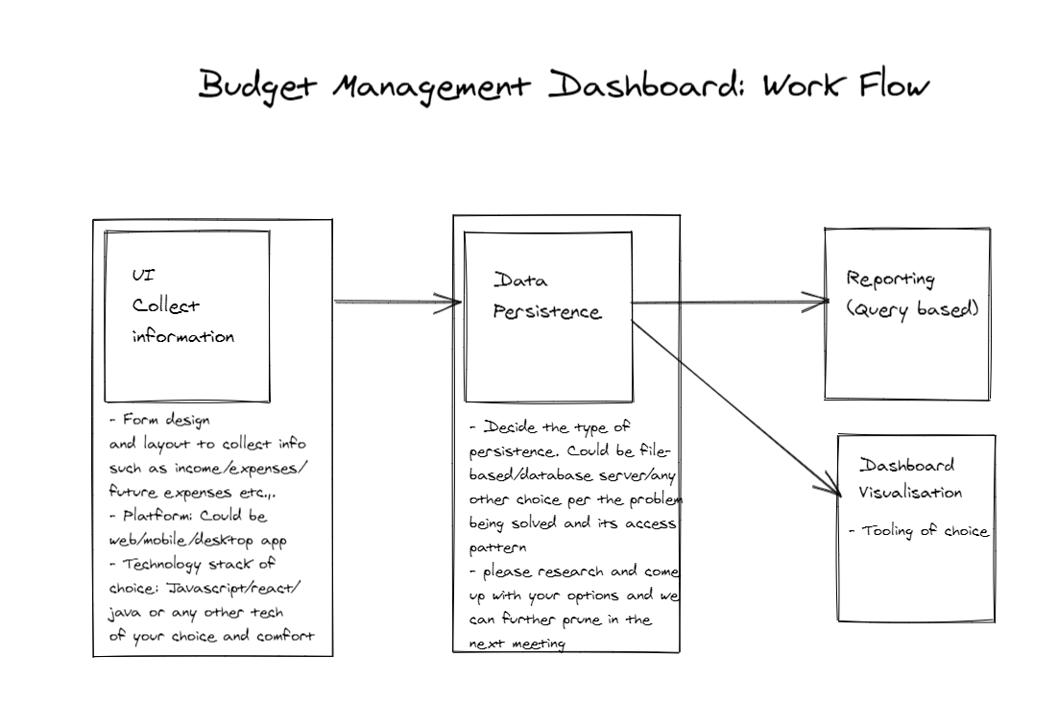

# Architecture & Process Flow Diagram

## System Context Diagram

Draw System context flow diagram which depicts the solution to the budget management dashboard. This will be a system design that clearly outlines the problem solution.

Helper link: <https://c4model.com/#SystemContextDiagram>

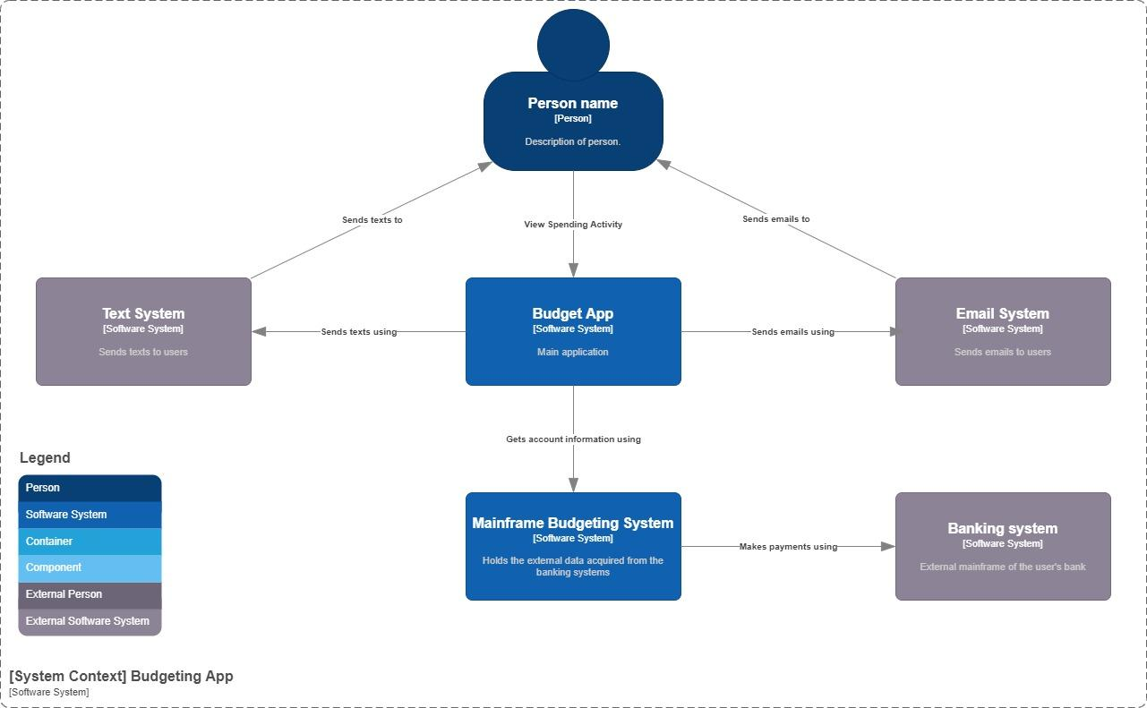

## Component Diagram

Draw each component that is planned to build based on the system context flow diagram. Each component should be built separately in a loosely coupled manner. The Component diagram shows how a container is made up of several "components", what each of those components are, their responsibilities and the technology/implementation details.

Helper link: <https://c4model.com/img/bigbankplc-Components.png>

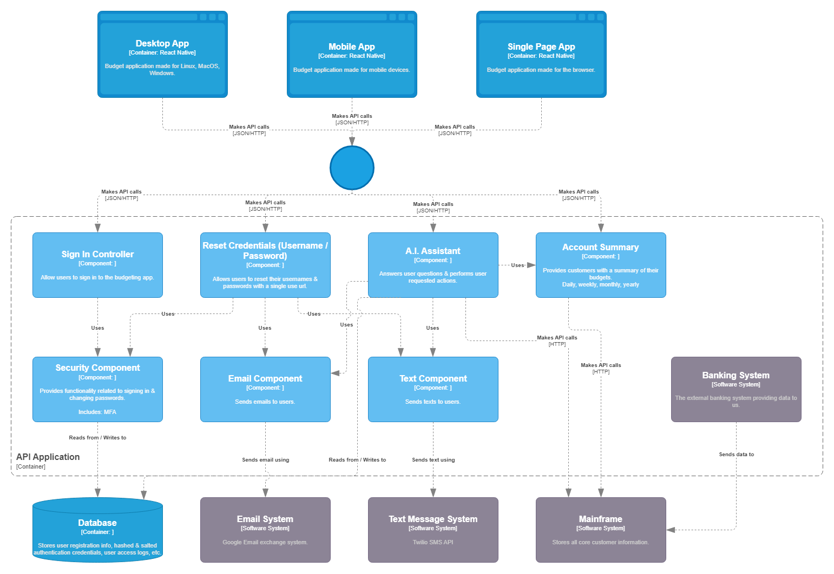

## Mockup Screens / Code

Screen mockups or develop code if you can build code (but not required) to support the solution.

